Title of the presentation

SURNAME¹ N., SURNAME² N. and SURNAME³ N.

¹ Affiliation (email@address.com)
² Affiliation (email@address.com)
³ Affiliation (email@address.com)

ABSTRACT
Cox [1] connected the elastic modulus of two-dimensional fiber network $E_{n}$ to the elastic modulus of a single infinitely long fiber $E_{f}$ (Eq. 1).
$E_{n} =E_{f}/3$ (1)
Any suitable equation editor is fine.
Figure 1 shows a reconstructed example of a 3D fiber network.
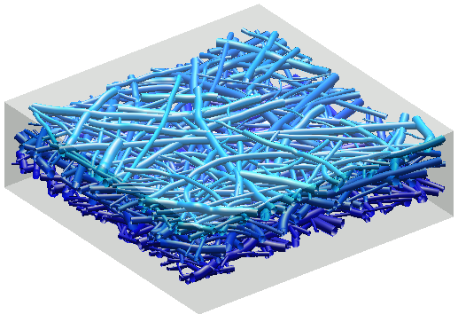
Figure 1. A reconstructed example of a 3D fiber network.

[1] Cox H.L. The elasticity and strength of paper and other fibrous materials. British Journal of Applied Physics, Vol. 3(3), pp. 72-79, 1952.

